Quiz 2

Problem solving: Pseudo Code and flowcharts
Q1. Study the flowchart given below.
 | Customer Type | Amount | Product Type
a. | Not Student | 8000 | TV
b. | Student | 4000 | Phone
c. | Not Student | 15,000 | Phone
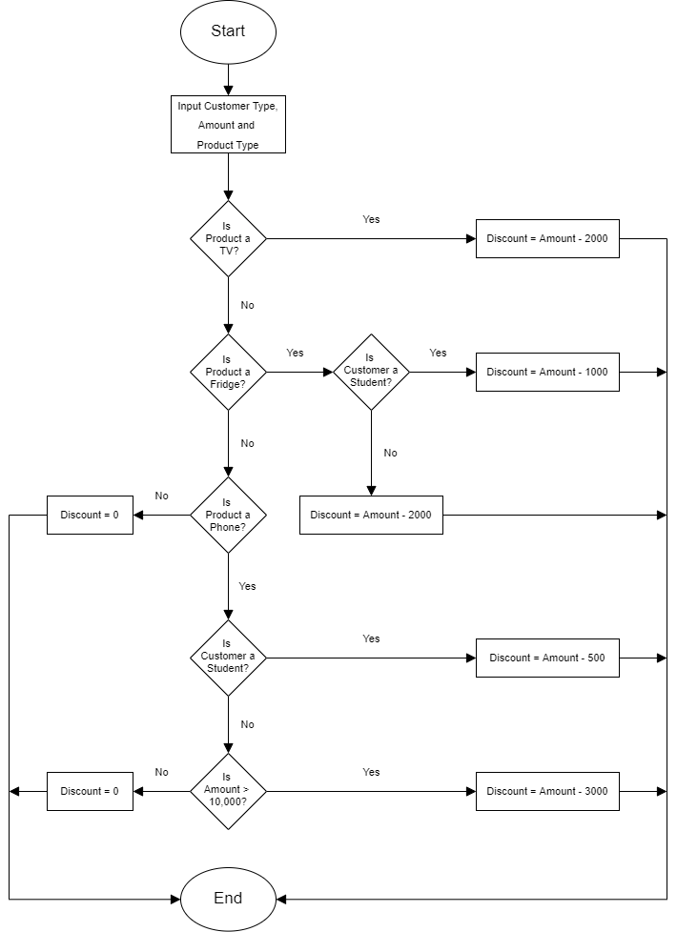
Calculate the discount for the following inputs:

Q2. Write an algorithm to check that a year is a leap year or not. A leap year is exactly divisible by 4 except for century years (years ending with 00). The century year is a leap year only if it is perfectly divisible by 400.
For example,
1999 is not a leap year
2000 is a leap year
2004 is a leap year

